Personal Portfolio Website Plan

# Your Name:

# Ideas for your website

Determine how you will use your personal portfolio website to showcase your skills.

Idea 1:

Display my past work experiences and resume.

Idea 2:

Display my school and work references organized on one page.

Idea 3:

My school schedule for the rest of the year, and the skills accumulated to this date.

Idea 4:

A general about me page and contact information.

Idea 5:

Include programs I have written.

# Website Plan

|  |  |  |
| --- | --- | --- |
| Topic | Questions | Answers |
| Purpose of Website | What is the purpose and goal of the website? | To showcase my skills, education, and resume. |
| Target Audience | Describe the target audience (age, gender, demographics) | Employers. |
| Graphics | What graphics will you use on the website? | I hope to include many pictures and visually pleasing aesthetics that match my energy and work ethic. |
| Color | What colors will you use within the site to enhance the purpose and brand? | Mostly monochrome with a light cascade of green or general pops of color. |
| Accessibility | How will the website accommodate people with disabilities? | Alt text, screenreaders, colorblind options, text size, big clickable things rather than small. |
| Project Timeline | Identify the project timeline | Unknown. This could be a month project or a year. |

# Wireframe

Sketch the wireframe for your home page below.



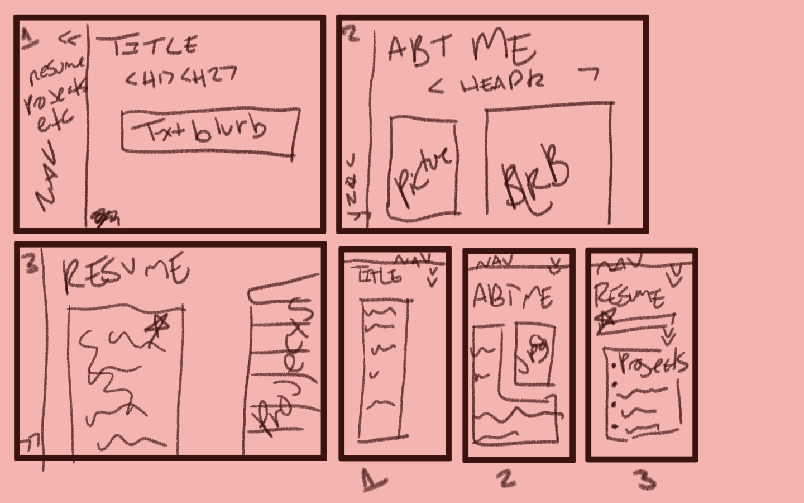



# Site map

Create a site map for the website below.

